**Experiment No.3**

**Aim**: To implement two‐sample Z‐test.

**Prerequisites**: python.

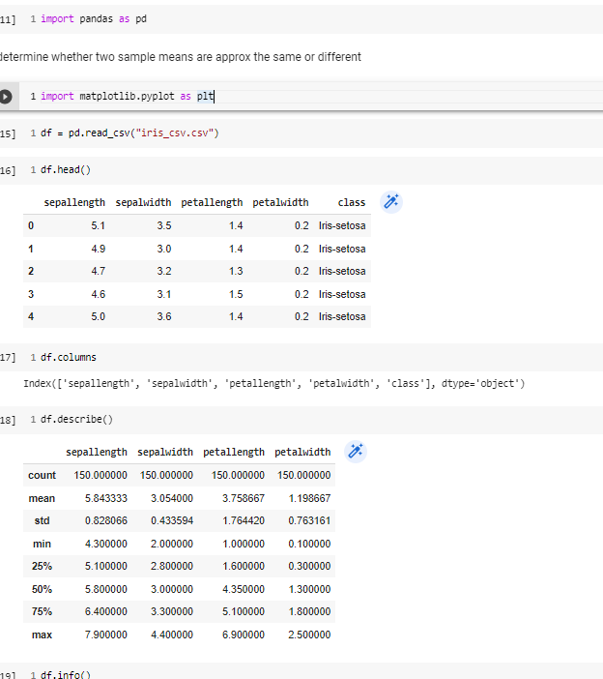

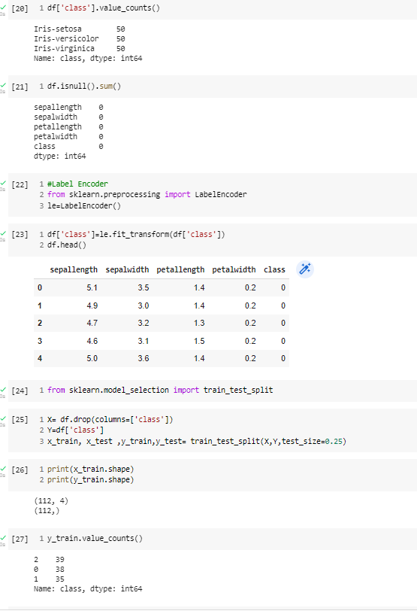

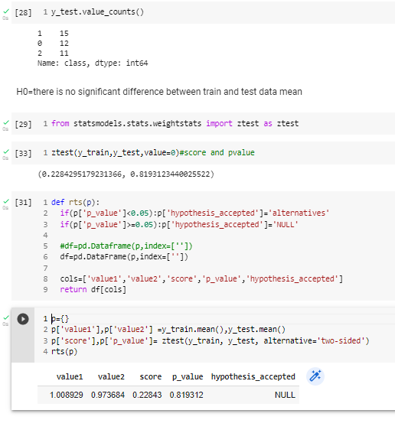

Conclusion: - In this experiment, we have validated dataset by performing two-sample Z-test